The Off-Grid Zero Emissions Building (OGZEB)

Hybrid Thermal/Electrical Energy Storage System

Team 15/23:

Corey Allen | Anthony Cappetto | Kristian Hogue | Tristian Jones | Nicholas Kraft

Lucas dos Santos | Artur Nascimento

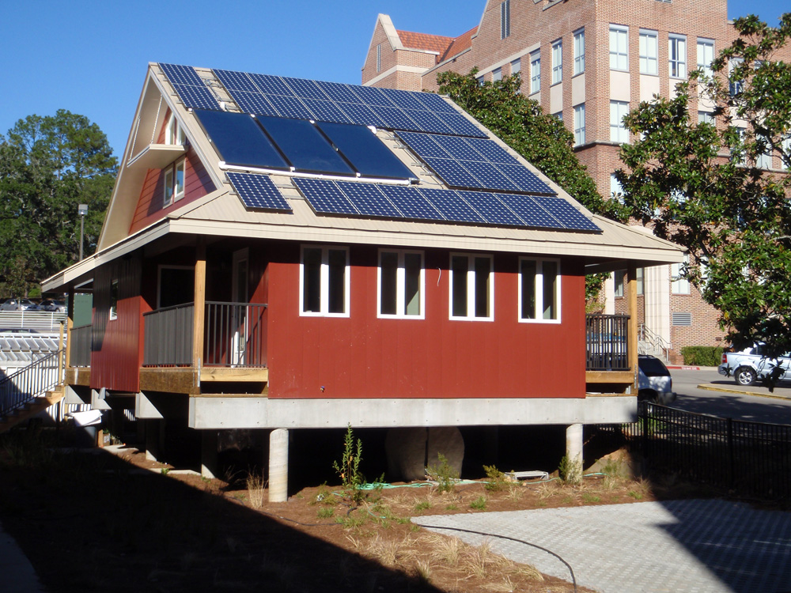

Advisers/Coordinators:

Kamal Amin | Michael Frank | Helen Li | Juan Ordonez | Jim Zheng

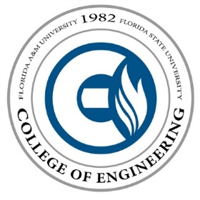

Contents

1. Problem Statement 3

2. Background 3

3. Objective 3-4

4. Methodology 4-5

5. Expected Results 5

6. Constraints 5-7

7. Design Requirments 7

8. Gannt Chart 8

**Problem Statement**

The purpose of this senior design project is to engineer an energy storage system that can harness the excess energy derived from the OGZEB’s solar panels. In addition to storing this energy, the improved design will also possess the capability to redirect this energy back to the power grid. With this capability, the home owner will be able to fully power their house during times of lower energy production and sell the excess energy back to the power company. In order for this system to meet the goals stated (see Objectives) and maintain the LEED (Leadership in Energy & Environmental Design) platinum certification, our team must upgrade the buildings battery network and develop a thermal energy storage system to work alongside the batteries.

**Background**

The OGZEB (Off Grid Zero Emissions Building) is located on the Florida State University campus. It is a 1064 square foot platinum LEED NC certified building. The building is split into an 800 square foot graduate style flat and 264 feet of offices. The building is also an actively used laboratory that is operating 24 hours a day. All the energy in the building is either converted from geothermal, solar thermal, or photovoltaic panels. Together, all of these energy sources give power to the OGZEB.

Most of the energy used by the OGZEB is provided by solar energy. In Florida, solar energy is widely available which makes it one of the most ideal solutions for powering the OGZEB. A 6.9 kW solar array converts the sun’s rays into electrical energy. However, the OGZEB will not need this much energy on an average day. The extra electricity is currently used to charge a series of batteries, to be used during nocturnal hours when the solar cells are not producing enough energy to meet the house’s needs. In the event of total battery drainage, the house is powered by a hydrogen fuel cell using pre-purchased hydrogen. The batteries currently in use are close to expiring. These batteries are very expensive to replace, so in an effort in sustainability, this project was established to develop a replacement energy storage system.

**Objective**

The main objective for the OGZEB is to develop an energy management system that is more reliable and efficient than the current system in place. The SR-230 solar panels are producing an excess amount of energy (~6.9 kW) and the load is only using about 17% of that energy. Since the solar panels are not producing a constant source of energy, creating an energy storage system is the most important objective of the OGZEB project.

Although the energy storage aspect of the project takes high priority, there are other goals that cannot be neglected and some others that will make the process easier. These objectives are as follows:

1. Design a combined thermal and electrochemical system.
2. Minimal power loss.
3. Stay within budget.
4. Maintain a Platinum LEED certification.
5. Create a system that can be easily tested and maintained for future research.
6. Sell back some excess energy by connecting to the commercial power grid (if there is time).
7. Design a system simple enough to be mass-marketable or at least reasonably reproducible

**Methodology**

Planning and goal setting is a vital first step to completing any project of significant magnitude. To begin work, it is necessary to have a thorough understanding of the problem being solved. This step would involve the completion of a needs assessment and close communication between the customer and the design team. The OGZEB project is nearing completion of this stage, having completed the needs assessment and met with all of the project advisors. Our next step is to conduct background research on possible solutions and the problem in general. This research should be expansive enough to encompass a number of types of solutions. Particular research emphasis will be given to thermal storage systems, but will also be expanded to energy storage in general. The research phase of the project will continue throughout the project as new situations develop. The next step in the project will be a combined ideation and evaluation process. Current technologies will be evaluated for their effectiveness and other qualities such as cost and feasibility. Concurrently, the team will attempt to generate new energy storage ideas. Once the team feels enough options have been evaluated, a selection will be made using at least one selection process.

After a design is selected, the detailed design and analysis phase will begin. This phase will involve the sizing and configuration of all physical components. The arrangement and specification of all electronic equipment also occurs during the phase. Heavy analysis will be utilized to ensure theoretical operability of the system and also to optimize the system for qualities such as efficiency and compactness. Once the detailed design is complete, the team will begin the procurement process. In theory this would be as easy as buying or building parts that fit our design. But in reality, the purchasable parts may vary significantly from the design necessitating design revisions and further analysis. Once all the parts are received, the building phase will begin. The building phase could also initiate design changes if parts don’t fit together as originally planned. Once the prototype system is fully constructed, the team will begin testing the prototype to see if it performs as intended. If it does not, more design revisions would be necessary, possibly requiring additional procurement, build, and testing phases. Once testing is complete, the system will be fully operational and ready for implementation on the OGZEB. Another possible route is to create a small scale prototype as a proof of concept and conduct testing on it, then scale up the system for implementation on the OGZEB.

**Expected Results**

With the conclusion of this project, we expect to have designed and built a hybrid thermal/electrochemical system that can store the excess energy generated by the photovoltaic panels in the OGZEB and have the system fully implemented by the end of the second semester. The project should meet all or most of the major goals listed in the objectives section. Furthermore the system should satisfy the desires of the customer in all aspects.

**Constraints**

Every adequately sized project has its fair share of obstacles. The Hybrid Energy Storage System will have a variety of obstacles and constraints associated with each step of the process. At the outset of the project some of the greatest complications can be broken into five different categories: Communication, Budget, OGZEB, Data Acquisition (DAQ), and Knowledge gap.

*Communication Constraints*

Communication is one of the greatest constraints every group assignment/project in any career field; ergo it is the first issue that must be controlled in order to achieve success. Because this project is comprised of two different Engineering disciplines at the FAMU & FSU College of Engineering, most of the communication difficulty arises in the different scheduling of both departments. Because both senior design classes do try to align themselves as well as possible, much of this error is avoided but some will always occur as they are two different classes. An example of a communication error could be when the initial meeting with the OGZEB research group occurred. The Mechanical Engineering side of the group had yet to meet the Electrical Engineering side of the group, so the meeting with Dr. Ordonez and his research group was scheduled without the knowledge of the Electrical Engineering department’s schedule. Since the meeting was scheduled during the Electrical Engineering senior design lecture, the Electrical Engineering side of the group had to skip their lecture. During the meeting the error was resolved because both sides of the group got on the same page and a weekly progress meeting was scheduled. Mechanical Engineers (M.E.) and Electrical Engineers (E.E.) very often work together in the field because of the broad spectrum of knowledge both disciplines contain. Although our knowledge of energy storage is similar, there are differences in the types of energy storage both disciplines are familiar with. Mechanical Engineers are more knowledgeable about thermal energy storage whereas, Electrical Engineers are more familiar with the electrochemical energy storage (battery) side of the project. A third communication difficulty can arise from having two foreign exchange students from Brazil as part of the group. Although we are fortunate to be able to work with them and share our knowledge, the language barrier could be an issue especially when it comes to group presentations or report writing.

*Budget Constraints*

A budget has not been clearly defined for this project which can be both good and bad. This can be good because there is less of a limit when it comes to design cost. The budget will be better defined after a clear design concept of the energy storage system has been approved. Some difficulty can arise because part of our task while designing the system is to be cost effective so the group must keep this in mind at all times. When the amount of funding isn’t truly defined, it is harder to keep track of which makes it more difficult to stay financially organized throughout the design process. In order to stay financially on track, an excel spreadsheet will be used to keep track of money coming in and going out.

*OGZEB Constraints*

Another constraint in the design of a new hybrid energy storage system is maintaining the standards of a platinum LEED (Leadership in Energy & Environmental Design) certification. The OGZEB house is platinum certified which is the highest level of LEED certification by the U.S. Green Building Council (USGBC)1. LEED is a point based system where building projects earn LEED points for satisfying specific green building criteria. Within each of the seven LEED credit categories, projects must satisfy particular prerequisites and earn points. The five categories include Sustainable Sites (SS), Water Efficiency (WE), Energy and Atmosphere (EA), Materials and Resources (MR) and Indoor Environmental Quality (IEQ). An additional category, Innovation in Design (ID), addresses sustainable building expertise as well as design measures not covered under the five environmental categories. The number of points the project earns determines the level of LEED Certification the project receives. LEED certification is available in four progressive levels according to the following scale:

There are 100 base points; 6 possible Innovation in Design and 4 Regional Priority points

Certified 40–49 points, Silver 50–59 points, Gold 60–79 points, Platinum 80 points and above. 2

*Data Acquisition Constraints*

Because the group is designing an energy storage system for the excess energy coming from the PV panels, obtaining data from the facilities of the house will be crucial to determining the success level of our system. Because the senior design group is not part of the research team, access to the house facilities will have to come through outside sources such as different members of the research team. A member of the house research team will have to be present at all times while using the facilities or collecting data. Our limited access to the house facilities should not be too much of an issue because a member of the research team will be there more often than not and other members of the team are just a phone call or email away. The house does maintain a system for monitoring the energy usage and output of various systems of the house which our group intends to utilize heavily. However, the quality of some of this data is in question and is limited in what data it can report. Some degree of assumption will have to occur in order to proceed with some aspects of the design phase.

*Knowledge Gap Constraints*

Although the senior design group has a basic understanding of the majority of the OGZEB facilities from the engineering curriculum, for most of us, this is the first time inside the OGZEB and the first time dealing with real life solar powered/renewable energy systems. The group has the combined knowledge from our years as undergraduates in our specific fields but each individual’s knowledge is limited to their own individual experience whether it be an internship, research position, or solely knowledge from their class curriculum. It is always advantageous to have experience/background knowledge in an area before doing work in that specific area so extra research will be required to get up to speed with some of the facilities in the building. With the combination of our mentor professors and the assistance of the research team, the knowledge gap shouldn’t be too much of an issue but rather an opportunity to learn something new and innovative that can be applied later on in our career fields or in a more general setting.

**Design Requirements**

In order to design and build the most appropriate energy storage system for the OGZEB, it is necessary to meet some requirements. One of them is that the system has to be optimized, providing a reduced power loss, increasing the overall efficiency and making a better use of the energy available from the environment. The system must also have zero net emissions and also combine thermal and electrochemical portions. Besides those requirements, economical aspects should also be considered, so that, a minimum upkeep is expected, as well as the budget should not be changed.

References

1. OGZEB Overview. Florida State University and Sustainable Energy Science and Engineering Center. 9-26-13. <http://esc.fsu.edu/documents/ogzeb/OGZEBpacket.pdf>

2. LEED Green Building Certification System. US Green Building Council. 9-26-13.<http://www.usgbc.org/Docs/Archive/General/Docs3330.pdf>